### DIGITAL MARKETING

### BUILDING A WEBSITE USING CANVA

### A PROJECT REPORT

***Submitted by***

**DEV ANANTH M (NM ID: 6AD771811ACB864B7D84CB97413BAE73)**

**LINGESHWARAN E (NM ID : 67DEE351D4C85708A11460F8244E491D)**

**DHARRUNKANNAN S ( NM ID: F72AB7F470AC7D0B001459B78BB229CF)**

**ROVAN M (NM ID: 7032B9600E7406FA64A4010364C46BA8)**

### TEAM ID : NM2023TMID4210

***in partial fulfillment for the award of the degree of***

### BACHELOR OF ENGINEERING IN

**DEPARTMENT OF COMPUTER SCIENCE AND ENGINEERING AAA COLLEGE OF ENGINEERING AND TECHNOLOGY**

**TABLE OF CONTENTS**

|  |  |  |
| --- | --- | --- |
| **CHAPTER NO.** | **TITLE** | **PAGE NO.** |
| **1** | **INTRODUCTION** | **3** |
|  | 1.1 PROJECT OVERVIEW | **3** |
|  | 1.2 PURPOSE | **3** |
| **2** | **PROBLEM DEFINITON & DESIGN THINKING** | **4** |
|  | 2.1 EMPATHY MAP | **4** |
|  | 2.2 IDEATION & BRAINSTORMING MAP | **5** |
| **3** | **RESULT** | **8** |
| **4** | **ADVANTAGES & DISADVANTAGES** | **15** |
| **5** | **APPLICATIONS** | **17** |
| **6** | **CONCLUSION** | **18** |

## CHAPTER 1

## INTRODUCTION

#### PROJECT OVERVIEW

In the realm of fashion, our T-shirt clothing project sets out to redefine style and sustainability. With a vision that marries the latest fashion trends with eco-conscious principles, our project aims to offer consumers a dynamic range of clothing that not only showcases their individuality but also contributes to a greener, more sustainable world.

Our brand is committed to producing T-shirts that make a statement - not just through their designs but also through the responsible materials and production processes we employ. We've meticulously sourced eco-friendly and sustainable fabrics, ensuring each garment is not just fashionable but also gentle on the environment.

One of the core pillars of our project is to reduce the environmental footprint of the fashion industry. We promote recycling, upcycling, and the use of biodegradable materials in our designs. Our innovative approach includes utilizing cutting-edge technologies to track and reduce the carbon footprint of our products.

Community engagement is at the heart of our project. We believe in creating a movement around eco-conscious fashion, organizing workshops, social media campaigns, and clothing rental services to empower consumers with sustainable choices.

Our commitment to transparency extends to partnering with eco-conscious influencers and collaborating with environmentally responsible suppliers. We encourage returning old clothing for recycling, fostering a circular fashion economy.

In this project, we're not just creating clothing; we're creating a revolution. A revolution that emphasizes quality, uniqueness, and eco-friendliness. Our T-shirt brand aims to be a beacon of style, innovation, and sustainability in the world of fashion, offering consumers the opportunity to express themselves while actively participating in the protection of our planet. Together, we are on a journey to redefine fashion and make a positive impact on our environment.

**Project title: KWEEK T-shirt Clothing Brand**

#### PURPOSE

## The purpose of our T-shirt clothing project is multifaceted and deeply ingrained in our commitment to redefining fashion for a more sustainable and responsible future. We aim to provide consumers with clothing that not only reflects their individuality but also aligns with eco-conscious values.

## First and foremost, our purpose is to offer stylish and unique T-shirts that empower individuals to express themselves while prioritizing the environment. By meticulously selecting eco-friendly materials and employing sustainable production methods, we aspire to reduce the ecological footprint of the fashion industry.

## We seek to raise awareness and promote eco-conscious consumer choices through educational initiatives, community engagement, and collaboration with like-minded influencers. Our project strives to inspire a cultural shift towards more responsible and sustainable fashion practices.

## Ultimately, our purpose is to lead by example, demonstrating that fashion can be both trendy and eco-friendly. We envision a future where consumers are not only fashion-forward but also environmentally conscious, contributing to a greener and more sustainable world through their clothing choices.

## 

## CHAPTER 2

**PROBLEM DEFINITION & DESIGN THINKING**

#### EMPATHY MAP

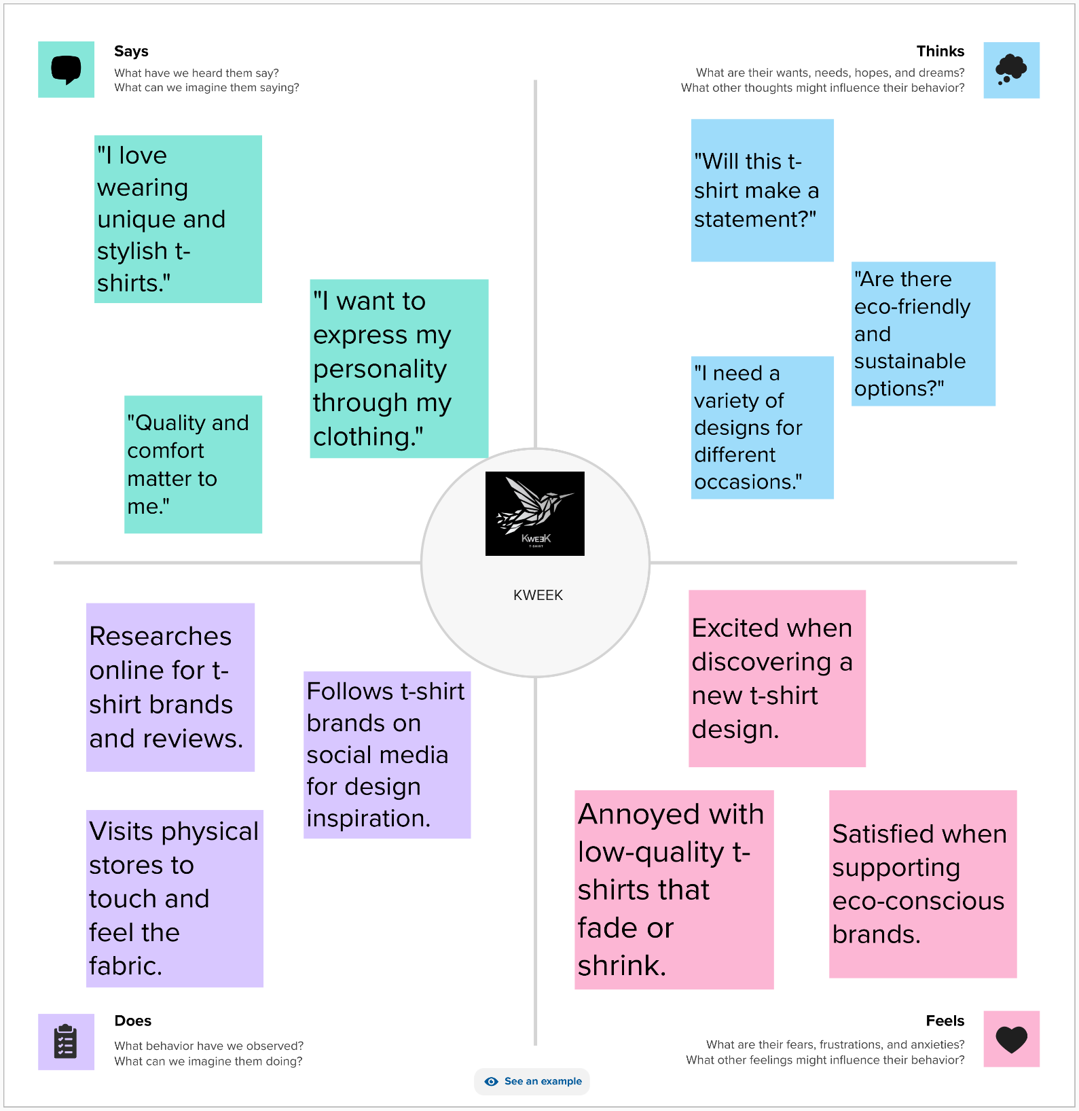

#### IDEATION & BRAINSTORMING

**Step-1: Team Gathering, Collaboration and Select the Problem Statement**

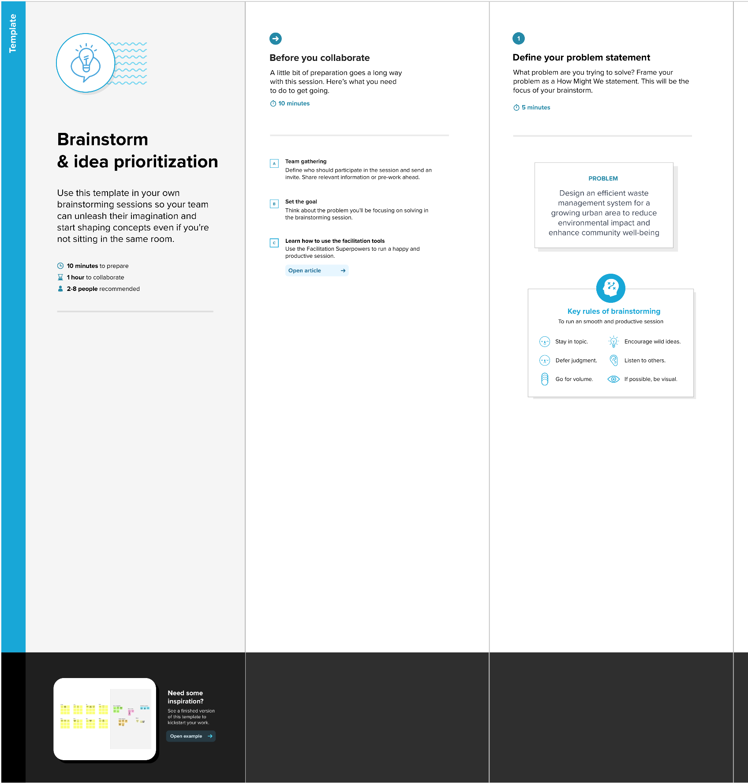

**Step-2: Brainstorm, Idea Listing and Grouping**

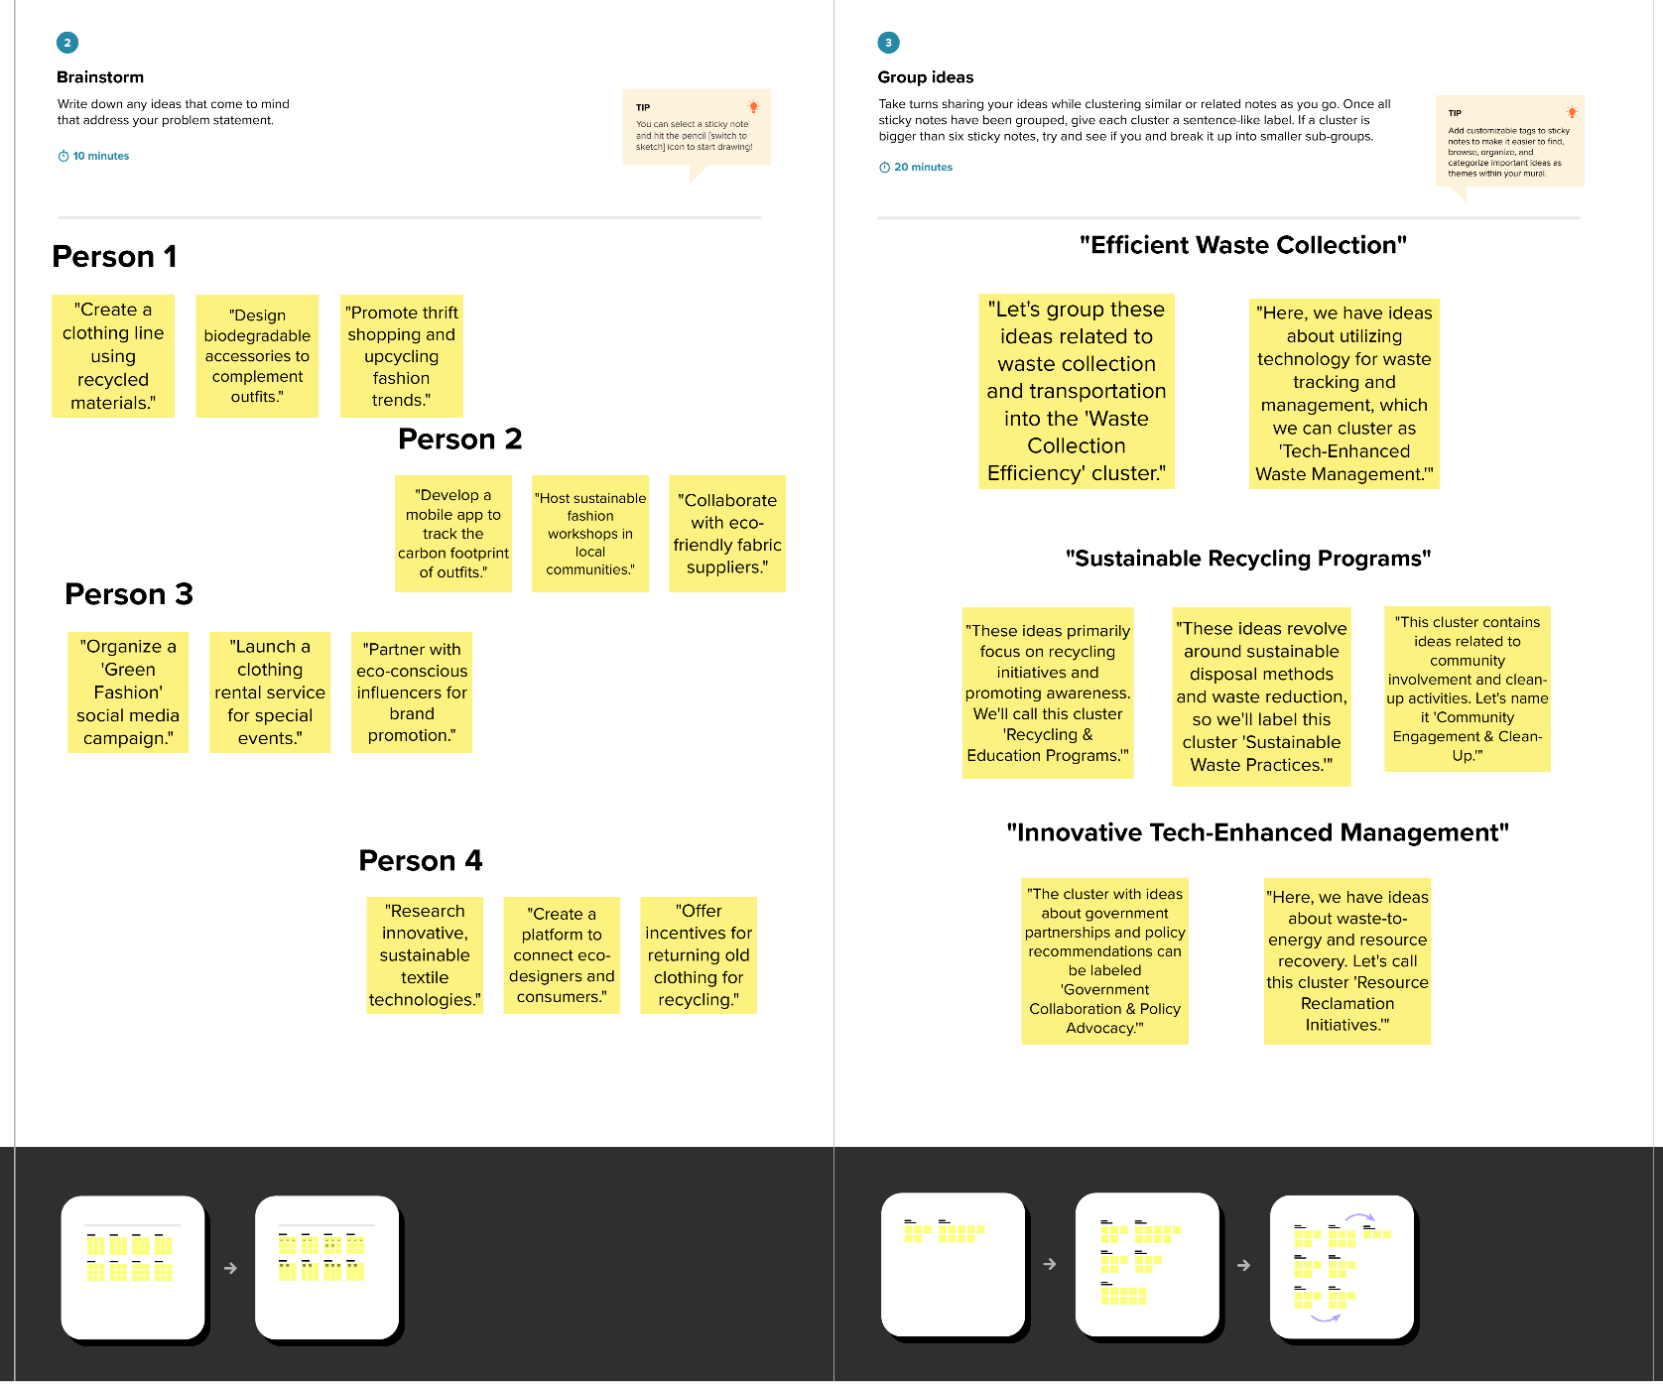

**Step-3: Idea Prioritization**

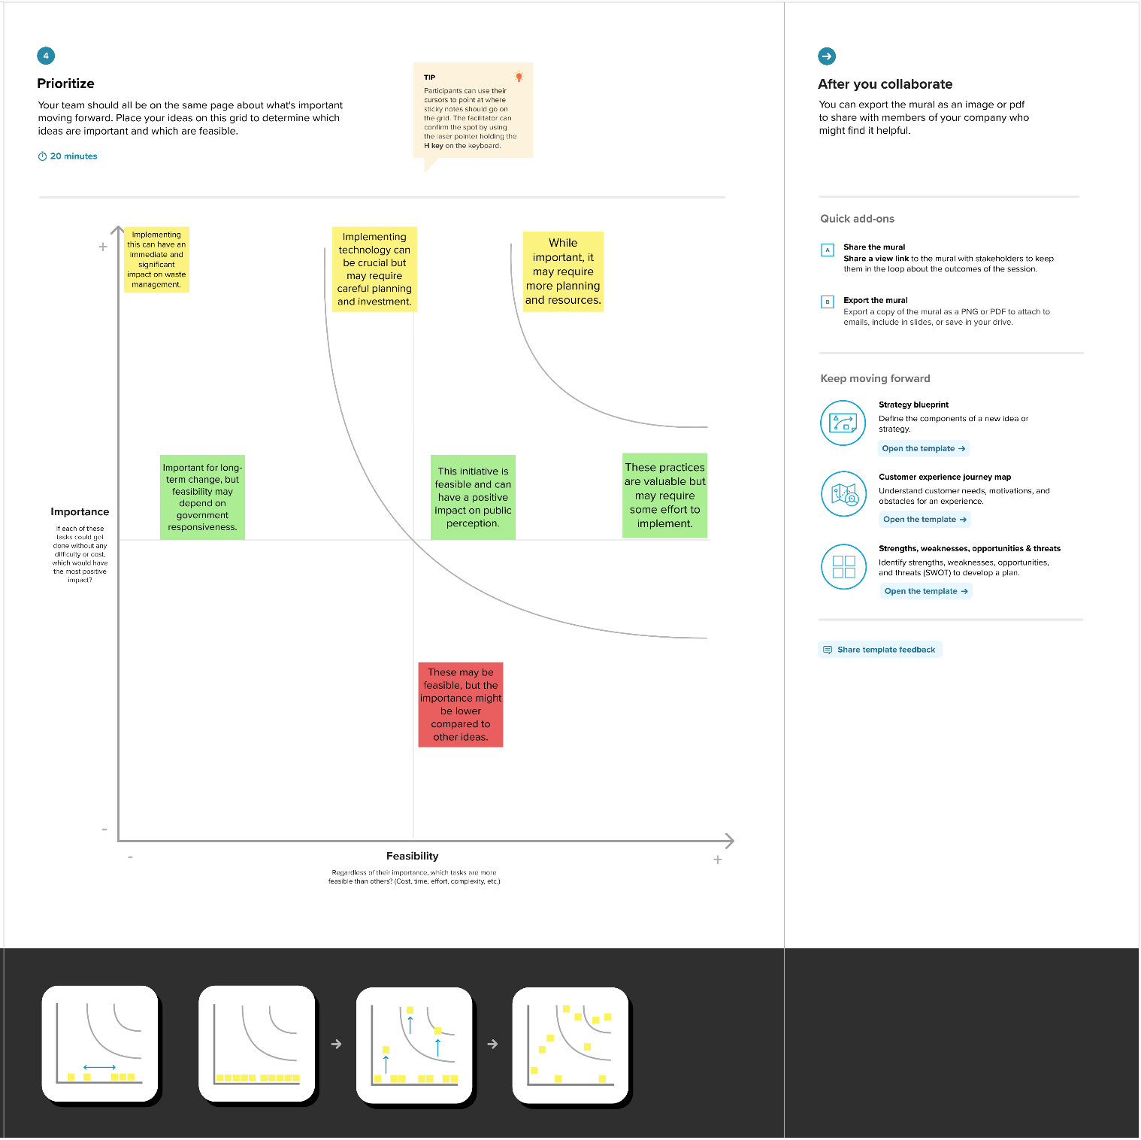

## 

## CHAPTER 3

## RESULT

**Brand Name:** KWEEK

**Category:** CLOTHING BRAND

**Target Audience:** All

**Email:**[kweek124589er@gmail.com](mailto:kweek124589er@gmail.com) **Password:** Your password here

**Instagram URL:**

## <https://www.instagram.com/kweek81/>

**INSTAGRAM PAGES:**

**HOME**

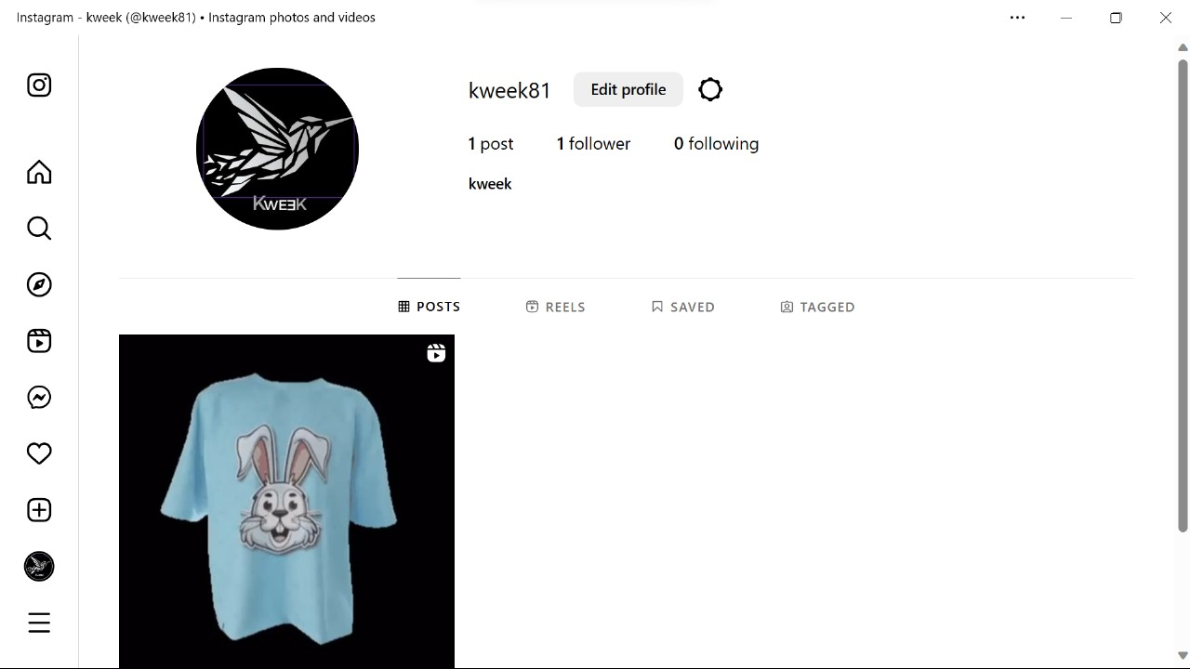

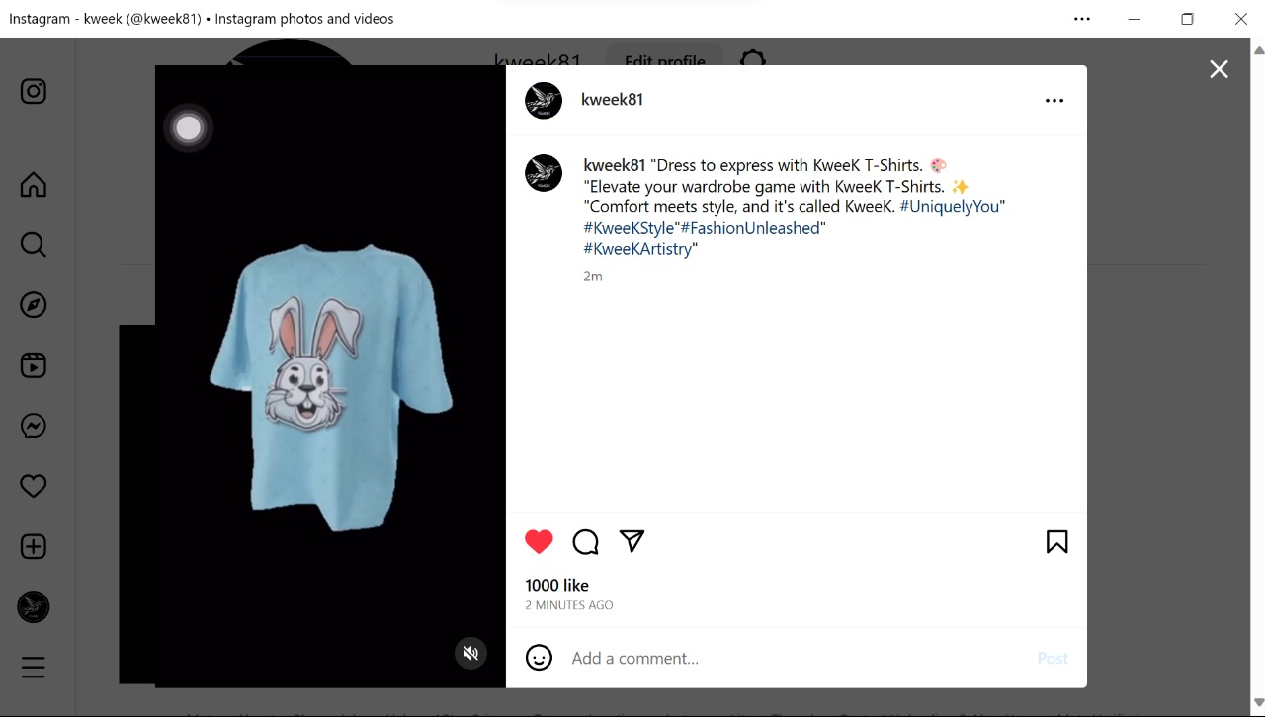

## CHAPTER 4 ADVANTAGES AND DISADVANTAGES

#### ADVANTAGES:

**Environmental Impact:** By using eco-friendly materials and sustainable production processes, the project reduces the environmental footprint of the fashion industry, contributing to the preservation of natural resources and the reduction of waste.

**Consumer Empowerment:** The project empowers consumers to make responsible fashion choices by offering eco-conscious options. It provides a platform for individuals to align their personal style with their environmental values.

**Innovation:** Through its commitment to using cutting-edge technology and materials, the project promotes innovation in the fashion industry, setting an example for others to follow.

**Community Engagement:** The project's workshops, social media campaigns, and events engage the community and raise awareness about sustainable fashion, fostering a sense of shared responsibility.

**DISADVANTAGES:**

**Higher Production Costs:** Eco-friendly materials and sustainable production methods can often be more expensive, potentially leading to higher production costs and, in turn, higher prices for consumers.

**Limited Availability:** Sustainable materials may not be as readily available as traditional ones, leading to potential limitations in product variety and availability.

**Consumer Education:** Promoting eco-conscious fashion requires educating consumers about the benefits and the importance of sustainability, which can be a time-consuming and ongoing effort.

**Competitive Market:** The sustainable fashion market is competitive, with many brands vying for market share. The project may face challenges in differentiating itself.

## CHAPTER 5 APPLICATIONS

**Fashion Retail**: The project can be applied to the retail sector, offering eco-conscious and stylish T-shirts to consumers looking for sustainable fashion options.

**E-Commerce:** E-commerce platforms and online marketplaces can host the project's product offerings, reaching a global audience of environmentally conscious shoppers.

**Eco**-**Fashion Boutiques**: Specialized eco-fashion boutiques can carry the project's clothing, catering to consumers seeking sustainable clothing options.

**Sustainable Fashion Events:** The project can participate in and contribute to sustainable fashion events and expos, showcasing its eco-friendly products.

**Educational Institutions:** Collaborating with educational institutions for workshops and fashion-related courses, promoting sustainability in fashion education.

**Environmental Awareness Campaigns:** Joining or initiating environmental awareness campaigns and initiatives to educate the public on sustainable fashion practices.

**Eco-Friendly Technology:** Collaborating with tech companies to develop eco-friendly clothing technologies, such as innovative fabric materials or carbon footprint tracking apps.

**Partnerships with Influencers:** Collaborating with eco-conscious influencers and celebrities to promote the brand and sustainable fashion ideals.

**Community Engagement**: Engaging with local communities to organize clean-up events, sustainable fashion shows, or workshops.

**Circular Economy Initiatives**: Participating in or initiating programs that promote the return and recycling of old clothing to reduce textile waste.

## CHAPTER 6 CONCLUSION

## In conclusion, our T-shirt clothing project embodies a transformative vision in the world of fashion, where style harmoniously coexists with eco-conscious values. Our commitment to sustainability, innovation, and community engagement forms the foundation of this endeavor.

## By offering eco-friendly materials and sustainable production processes, we reduce the environmental impact of the fashion industry. Our project empowers consumers to make responsible fashion choices, allowing them to express their individuality while respecting the environment.

## Through workshops, social media campaigns, and collaborations with eco-conscious influencers, we are fostering a movement that encourages sustainable fashion practices. We aim to make a significant positive impact on the world by promoting recycling, upcycling, and the use of biodegradable materials.

## Our project's transparency, innovation, and community engagement make us a beacon of style and responsibility in the fashion industry. We envision a future where consumers are not only fashion-forward but also environmentally conscious, making conscious choices to contribute to a greener world through their clothing.

## In embracing the values of style, sustainability, and community, we are not merely creating a brand; we are leading a fashion revolution. A revolution that proves that eco-conscious fashion is not just an ideal but a fashionable and attainable reality. Together, we are shaping the future of fashion for the better, one eco-friendly T-shirt at a time.